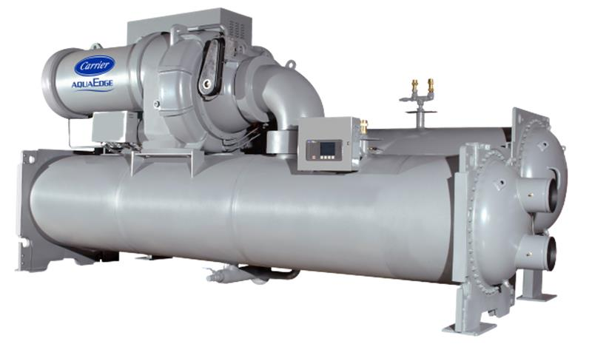

Chiller background

Chiller details | Information
Chiller Number | XXXXXXX
Location | XXXXXX
City | XXXXX
Year of Manufacturing (Age) | XXXX (XX)
Model Number | XXXXXXX
Chiller Run Hours | XXXXXX
Report Duration | XX-XXX-XX to XX-XXX-XX
Chiller Capacity (RT) | XXX
Rated Chiller Power (kW) | XXX
Design Leaving Chilled Water Temperature (ºF) | XX.X
Design Entering Condenser Water Temperature (ºF) | XX.X

Summary

As part of Carrier's connected service program, our command center experts continuously monitor the performance and health of the chiller and its major components.

The chiller with serial number XXXXXX underwent a chiller retrofit analytics program considering its age and run hours exceeding 20 years and 70,000, respectively. Further analysis was conducted using real-time data from XX-XXX-XX to XX-XXX-XX.

The chiller's design full load efficiency is X. XX kW/RT, while the computed chiller efficiency is X.XX kW/RT during the analysis period.

These are initial analytic and findings of a chiller performance from telemetry data within a specified period. Further investigation and energy assessment on chiller plant level are recommended to understand existing chiller plant baseline performance. Carrier offers in-house engineering tools to assist our customers in developing new solution with optimized configuration and operation.



Chiller Performance Analysis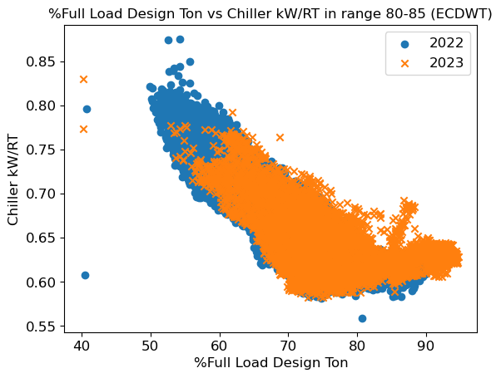
Comments
- The chiller efficiency (kW/RT) is steadily rising compared to the previous year, indicating an increase in energy consumption per unit of cooling output.
- This trend indicates a potential decline in efficiency, emphasizing the need for further investigation to address and rectify underlying issues.
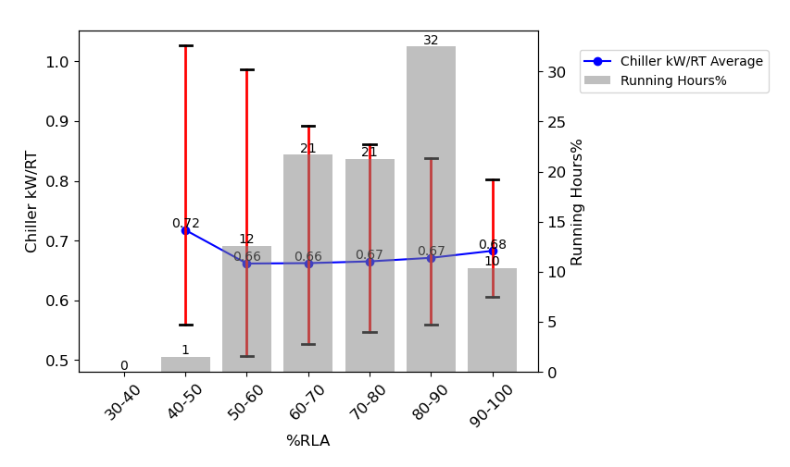
Comments
- This plot illustrates various part-load efficiencies based on specific criteria:
  - The chiller operates at full load for more than 80% of the time: No
  - The chiller frequently operates at less than 60% of its RLA for most of the time (more than 80% of the time): No
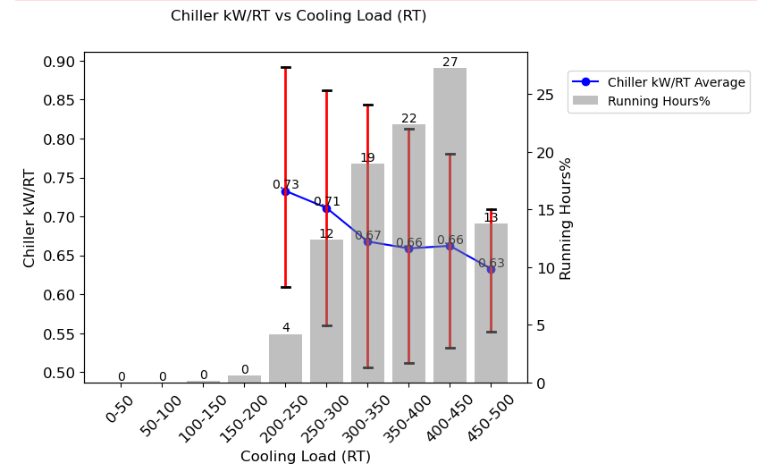
Comments
- This plot illustrates various part-load efficiencies at different Cooling Loads:
  - Most of the time (27%) chiller operates from 400 – 450 RT.
Chiller Alarm Analysis
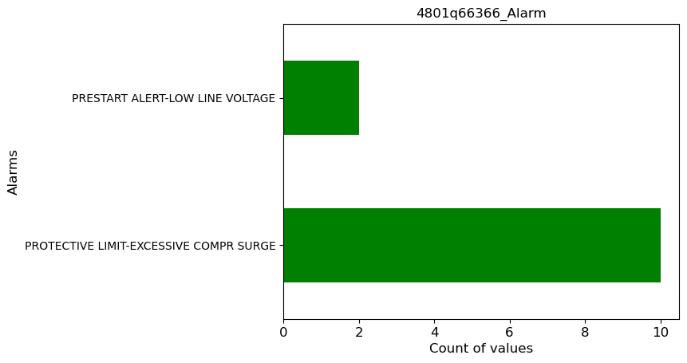
- The chiller device has total of 5 alarms during this analysis timeframe.
- There have been no instances of chiller device alarms exceeding 15 in the last 2 months.

Chiller Water Temperature Analysis
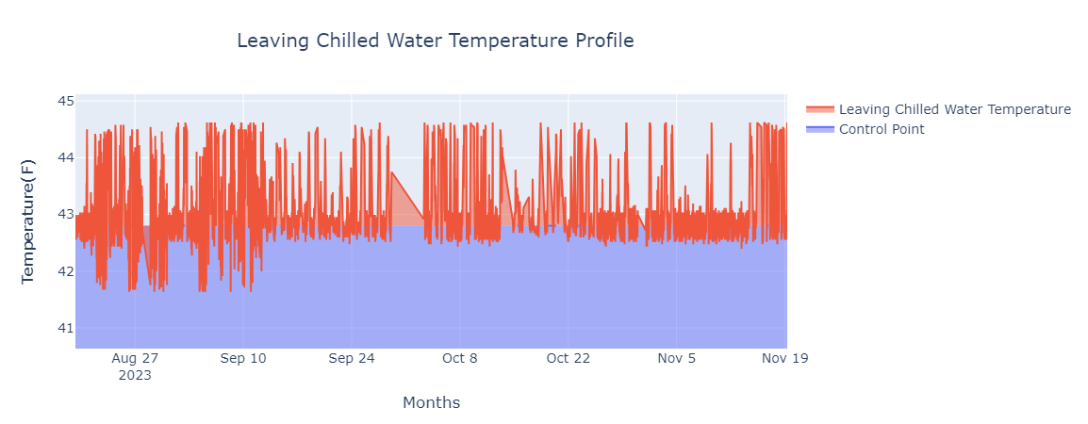
Comments
- The leaving chilled water temperature meets 93.23%, the set point.
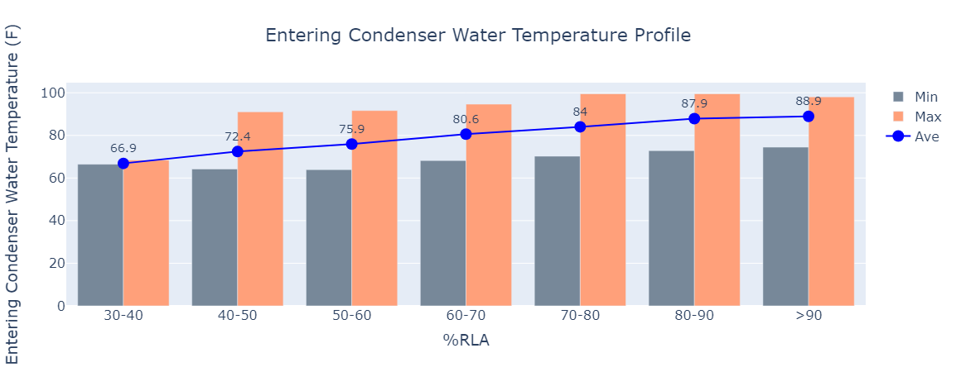
Comments
- The average entering condenser water temperature falls within the range of 66.9 ºF to 88.9 ºF.

Chiller Data 2022(Average)
Year 2022 | Jan | Feb | Mar | Apr | May | Jun | Jul | Aug | Sep | Oct | Nov | Dec
Entering Chilled water temperature, °F | - | - | 49.9 | 51.7 | 50.0 | 52.6 | 51.5 | 49.9 | 50.3 | 49.2 | 49.1 | 49.0
Chiller power consumption, kW | - | - | 247 | 307 | 280 | 320 | 292 | 264 | 289 | 244 | 257 | 268
Chiller efficiency, kW/RT | - | - | 0.61 | 0.60 | 0.63 | 0.65 | 0.74 | 0.73 | 0.69 | 0.69 | 0.63 | 0.63
Cooling load, RT | - | - | 344 | 432 | 373 | 419 | 341 | 308 | 356 | 298 | 347 | 357
Entering Condenser water temperature °F | - | - | 76.3 | 80.3 | 81.0 | 85.4 | 87.8 | 84.9 | 85.1 | 80.8 | 78.4 | 80.0
Chiller energy consumption, kWh | - | - | 80,537 | 77,507 | 21,399 | 230,309 | 132,616 | 196,285 | 199,967 | 119,211 | 173,341 | 117,956

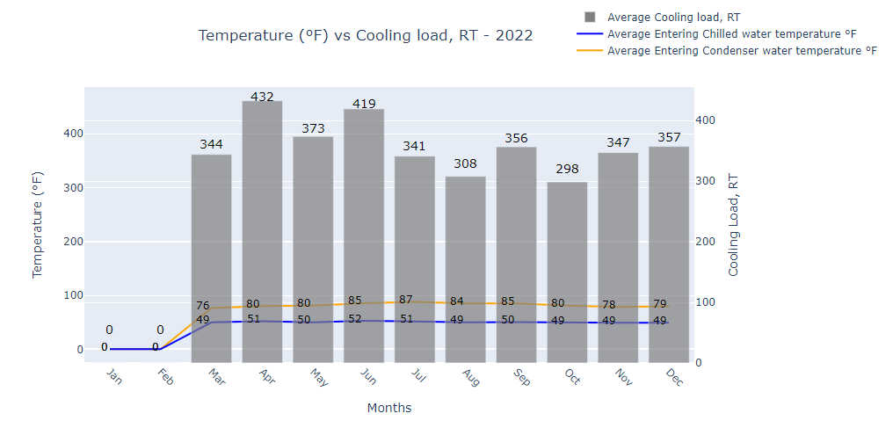
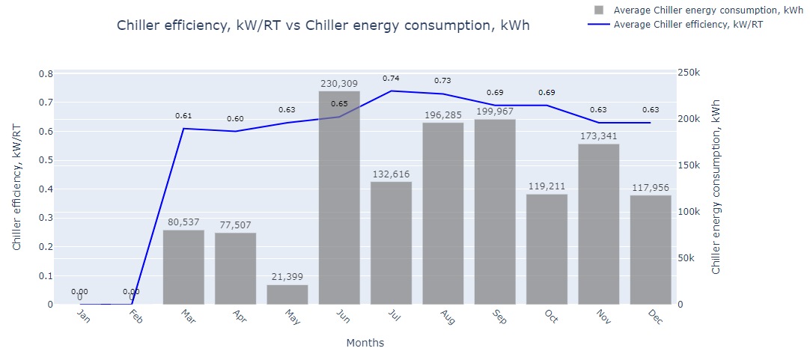

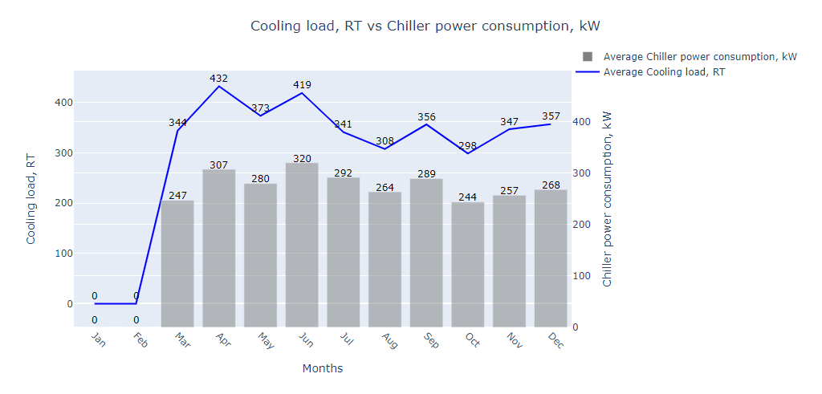

Chiller Data 2023 (Average)

Year 2023 | Jan | Feb | Mar | Apr | May | Jun | Jul | Aug | Sep | Oct | Nov | Dec
Entering Chilled water temperature, °F | - | 48.5 | 49.0 | 48.9 | 51.0 | 52.3 | 52.4 | 52.1 | 52.9 | 51.9 | 51.7 | -
Chiller power consumption, kW | - | 239 | 260 | 257 | 293 | 328 | 339 | 314 | 333 | 337 | 315 | -
Chiller efficiency, kW/RT | - | 0.63 | 0.63 | 0.63 | 0.59 | 0.67 | 0.70 | 0.72 | 0.69 | 0.64 | 0.60 | -
Cooling load, RT | - | 322 | 346 | 346 | 415 | 414 | 408 | 369 | 410 | 443 | 441 | -
Entering Condenser water temperature °F | - | 74.7 | 79.0 | 78.5 | 78.8 | 86.6 | 89.5 | 88.6 | 88.0 | 84.6 | 79.0 | -
Chiller energy consumption, kWh | - | 112,327 | 187,416 | 90,974 | 97,830 | 125,246 | 233,998 | 229,416 | 225,802 | 224,323 | 138,607 | -

